West Sussex Fun Run League

**Lewes AC Easter Monday Fun Runs**

**Monday 21st April 2025**

**Information for runners and supporters**

**1.** **Venue**

The start and finish will be near Race HQ which is trackside at Lewes Leisure Centre, Mountfield Road, Lewes BN7 2XG. Please follow signs to walk round to the back of the building rather than going through the Leisure Centre

**2. Race start times**

10k Race - 10.45 am  
Junior 1 Mile Race - 10.15 am  
Toddlers Trot 400m - 10.00 am

**3. Course**

**10k: start time 10.45am**  
Starts on the running track, leaves the track area and is essentially a largely flat loop south of Lewes to the village of Iford on a multi-terrain course comprised mainly of bridleways and foot paths with a short section of road through Iford village, then finishing back at the track. The majority of the course is surfaced, either gravel path, pavement or tarmac. Please note care should be taken on the first section of Ham Lane soon after you set off and pass the second pair of marshals outside the recycling centre - while the potholes have recently been topped up, the road surface is still uneven in parts. Shortly after there is a short section on the bridleway between the sodden fields towards Iford which can be muddy. After that section the remainder of the course is in good running condition. It is well signed and marshalled and comes in at a little over 10k. Map and link to GPS file below:

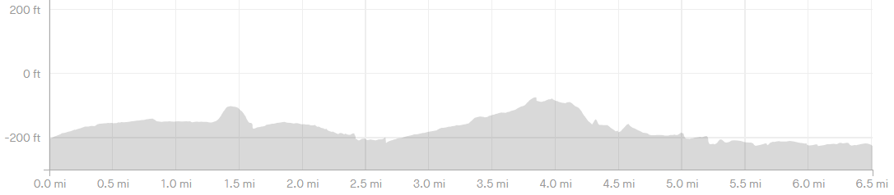

GPX file: LAC_Easter_Monday_fun_run_route.gpx

**Junior race**: **Approximately 1 mile start time 10.15am**Starts on the running track takes a half mile detour out through the Priory School grounds and Ham Lane.  Finishes back on the track.

**Toddlers Trot: 400m  start time 10am**One lap of the track

**4. Logistics**

Please car share if possible. Free car parking is available in the designated car parks (which will be well-signed; please do **not** park at the Leisure Centre). Alternatively Lewes train station is a 5-minute walk away. Refreshments are available at Race HQ, as are Portaloos.

**5. Race Timing**

Sport Systems will be timing the event using shoe timing chips.

We will provide runners with a "Race Time" calculated from when the race is started to when the runner crosses the finish line – this is sometimes called gun time – as well as a personal chip time.   
The results and prizes will be based on Chip Time order.

**6. Race Numbers, Chips and Race Information**

Race numbers and chips need to be picked up on the day of the race. Please allow extra time to do this. Race specific information will also be available on the race website <https://www.lewesac.co.uk/events/easter-fun-run>.

**7. Headphones and MP3 Players**

In line with WSFRL requirements, no headphones are permitted. You will be disqualified if you are found to be using them. Bone conducting headphones are permitted.

**8. Where can I find the results?**

The results for all WSFRL entrants will be uploaded to the WSFRL site. Results will also be posted on the results section of <http://www.sportsystems.co.uk> shortly after the race.

**9. WSFRL club entries**

Please submit your entries via SmartRs by the end of 15th April 2025. Number collection from Race HQ on the day.

Advance club entry fees are £7 for the 10k race and £2 for the junior race. Toddlers Trot is free. Payment to:

Account name: Lewes AC  
 Sort Code: 30-18-30  
 Account Number: 01414052

In the reference field please enter 'Easter 10k' and your club name. Payments no later than 16th April 2025.

For those who are **not** members of a WSFRL-affiliated club, entry is via the race website <https://www.lewesac.co.uk/events/easter-fun-run>

Good luck with your training and have a great run.  
The Sport Systems Team and Kate Seymour, LAC Easter Fun Run Race Director  
All enquiries, please email [wsfrl@lewesac.co.uk](mailto:wsfrl@lewesac.co.uk)